Thread Management using POSIX Library - Detachment and Cancellation

- Write a program to create 3 threads with the detach and cancel status as below.

Thread# | Detached (Y/N) | Cancel type | Cancel status
1 | Y | PTHREAD_CANCEL_DISABLE
2 | N | PTHREAD_CANCEL_ENABLE | PTHREAD_CANCEL_DEFERRED
3 | N | PTHREAD_CANCEL_ENABLE | PTHREAD_CANCEL_ASYNCHRONOUS

- Let all the threads read and display their detach, cancel type and status and then display thread specific message as below.
T1: Display message in the format as below every 2 secs
<timestamp> Health OK
T2: Print numbers starting from 1000 in steps of 2 at an interval of 3 secs in format as below.
<timestamp> <threadid> <countvalue>

T3: Print numbers starting from 2000 in steps of 2 at an interval of 3 secs
<timestamp> <threadid> < countvalue >

- After creating threads, and after 3 minutes from main(), cancel all 3 threads
- From an other terminal, use command below to view the thread count of your program
    - ps -eLF
    - top
[For top command usage to refer https://www.golinuxcloud.com/check-threads-per-process-count-processes/ ]
A: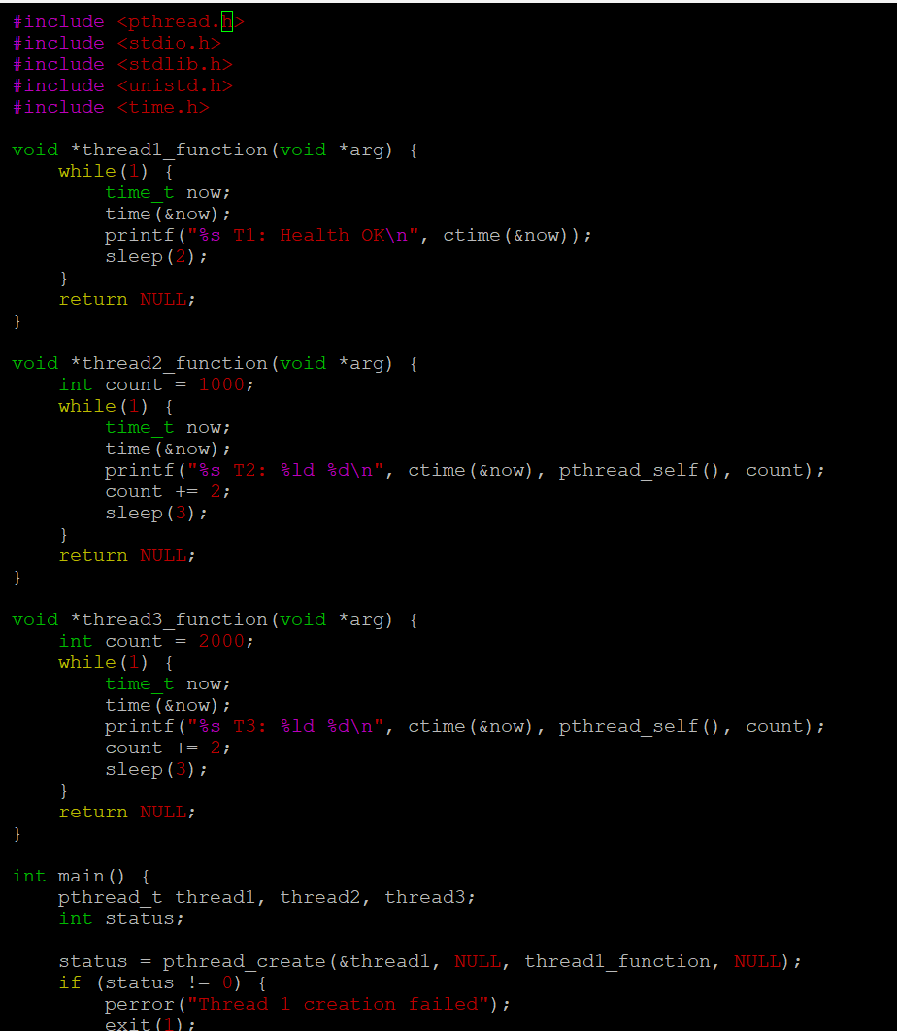
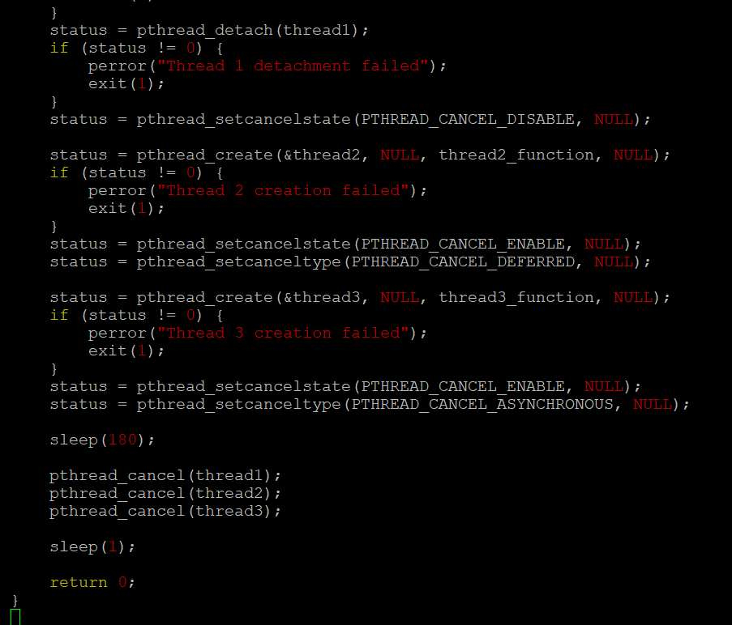
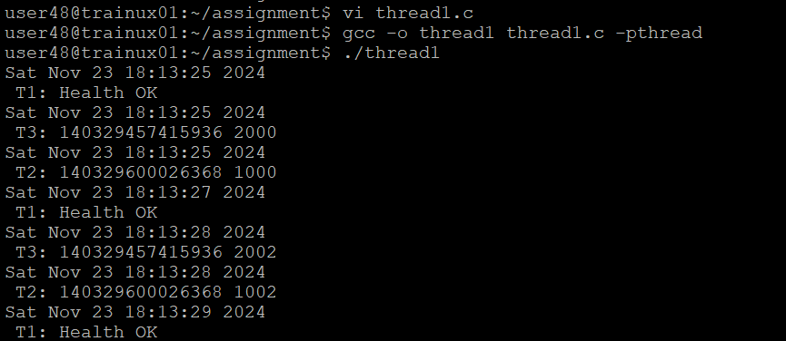

- What difference did you observe between top and ps command?
A: The ps command shows the threads as individual lines for a process with the -L option. It lists threads by their thread ID (TID) under the same process. In contrast, top shows a total number of threads and may show threads under the same process but in a less granular way compared to ps.
- Which column shows the number of threads in ps and in top commands?
A: * In the ps command, use the -L option to see the threads, and the column showing the thread count is labeled NLWP (Number of Light Weight Processes, which refers to threads).
* In top, the thread count is shown in the summary section at the top as Tasks and shows the number of threads.
- Check the last message timestamp from the threads
A:After canceling the threads, check the last printed timestamp in the console for each thread. The output of the program should show when each thread last printed a message before cancellation.
- Which thread was cancelled first and why?
A: *Thread 1, which is detached and has cancellation disabled (PTHREAD_CANCEL_DISABLE), cannot be canceled until the program terminates, so it won't be affected immediately.
*Thread 3, having asynchronous cancellation (PTHREAD_CANCEL_ASYNCHRONOUS), will likely be canceled first as it is immediately responsive to cancellation requests.
*Thread 2, with deferred cancellation, may continue running until it hits a cancellation point.
- Were all 3 threads cancelled? Justify the observation
A: * Thread 1 will not be canceled because cancellation is disabled.
*Thread 2 will be canceled after reaching a cancellation point (it is using deferred cancellation).
* Thread 3 will be canceled immediately due to asynchronous cancellation.

